Project 9: ABAQUS Sub-model with finer mesh

Problem Statement: Use sub-modeling approach to drive a local model with finer mesh in a static structural simulation.

Geometry:
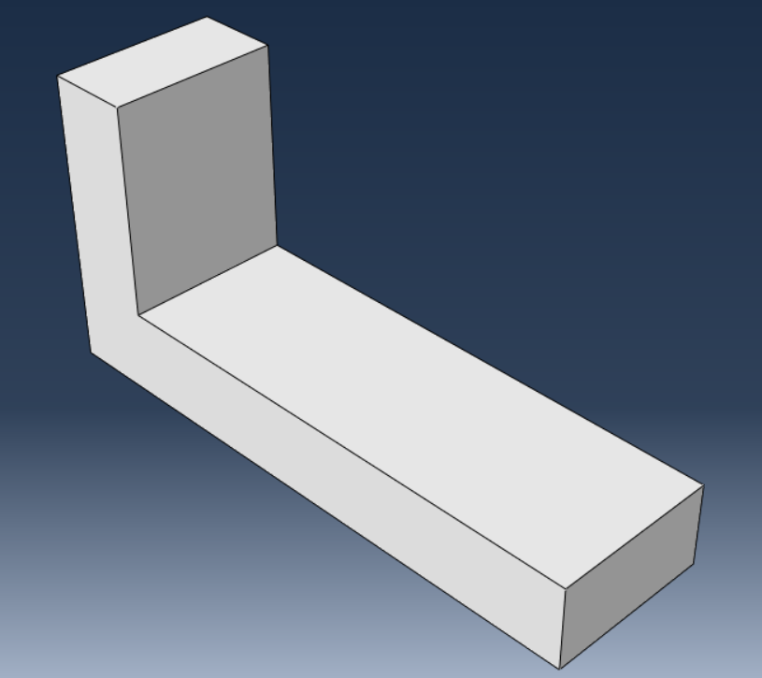

Material Properties:
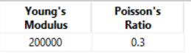

Loading and boundary conditions:
- Top surface in the left region is fixed. Top surface in the right region has a pressure load applied.
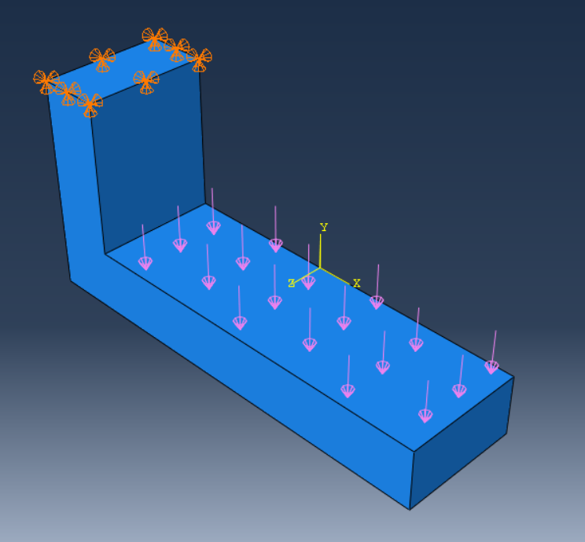

Mesh: (coarse due to limitation of 1000 nodes in ABAQUS educational version).
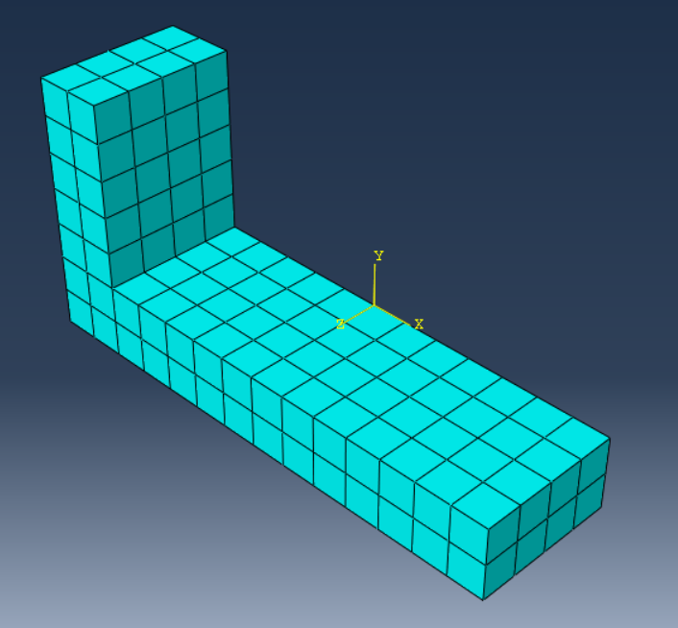

Results:
Deformation:
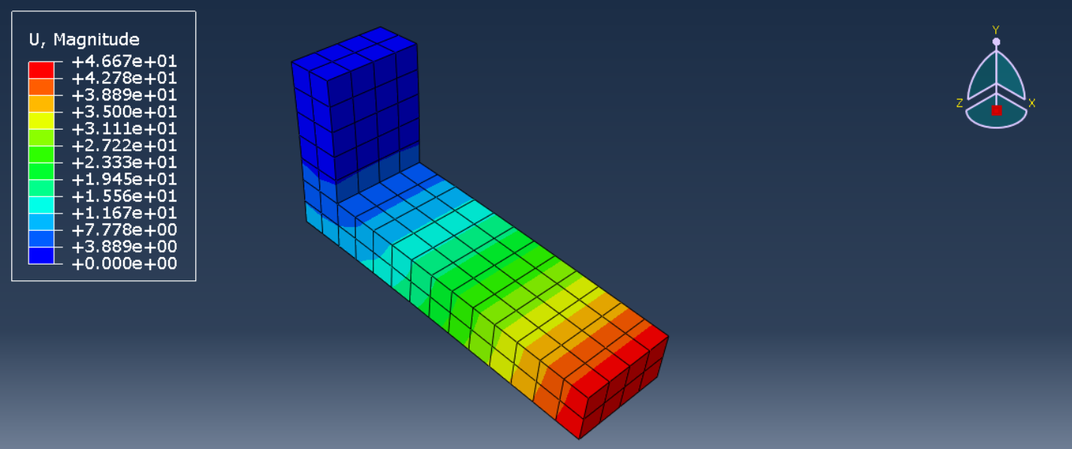

Mises stress:
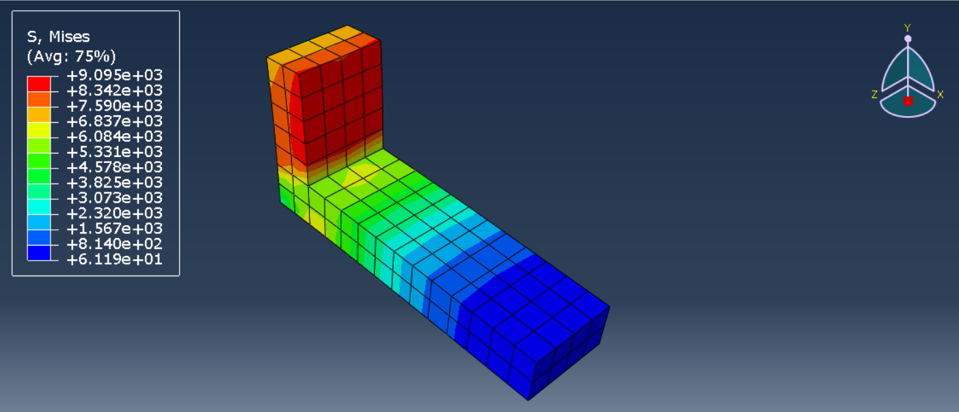

Sub-model (Left Region of the global model):
Geometry:
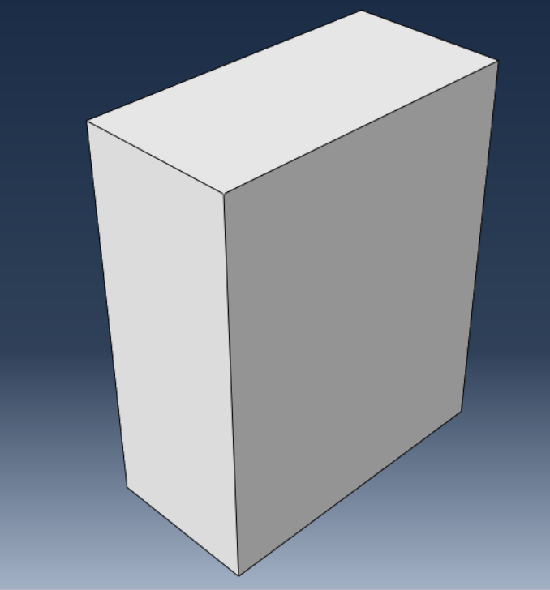

Loading and BC:
- Sub-modeling BC applied at the bottom surface.
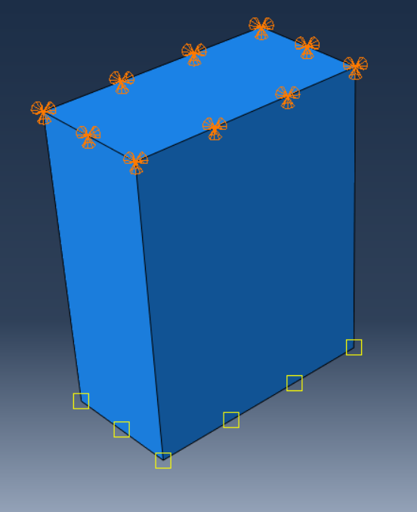

Results:
Deformation:
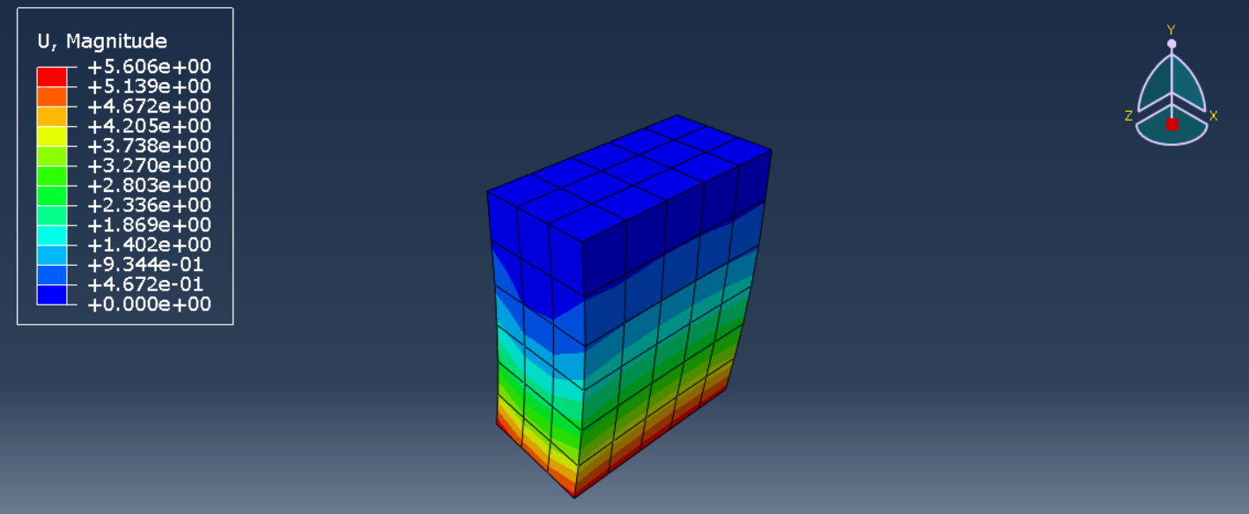

Mises stress:
